**File Structure Netflix Clone**

**Installation:**

npm i express jsonwebtoken mongoose cookie-parser dotenv axios bcryptjs

* Express: Package for Web Framework  
  JSON web token: For Authentication and for Generating Tokens
* Mongoose: For Mongo Database
* cookie-parser: For Parsing incoming Cookies
* Dotenv: To Deal with Environment Variables
* Axios: For HTTP client Alternative for Fetch
* Bcrypt JS: For Hashing

**Backend Setup**

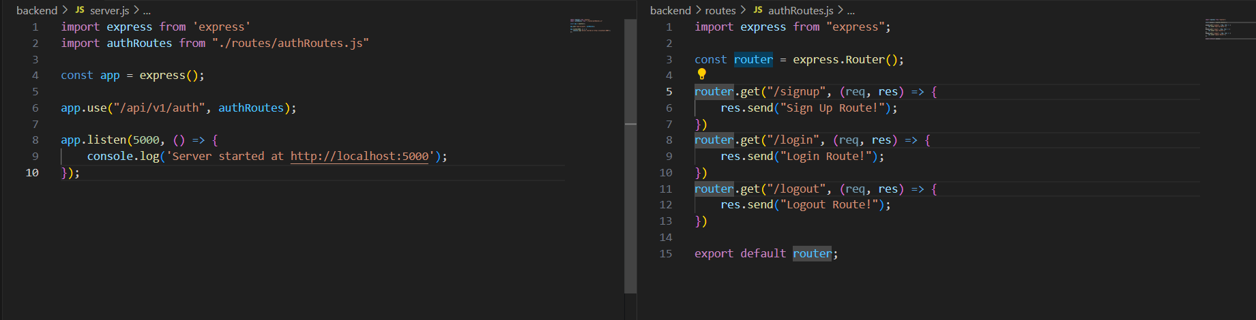

**Auth Route Controller for More**

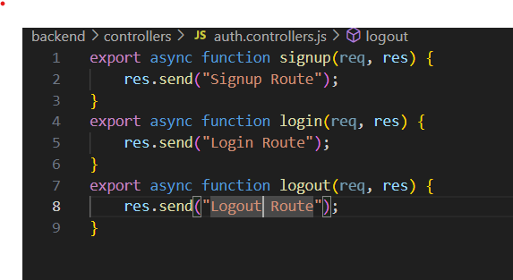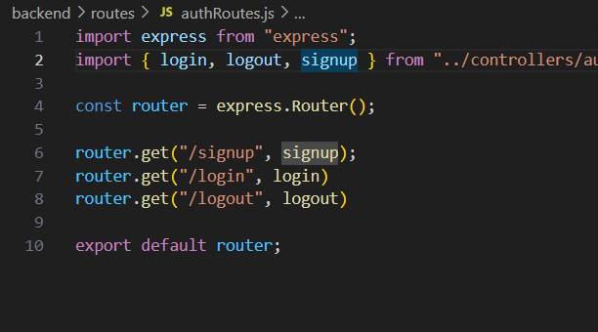

**Database Connection**

In Server.Js we call connectDB() in db.js we define the connection in envVars.js we define the port 5000 and call URI to build connection in .env we set the values for our database and port

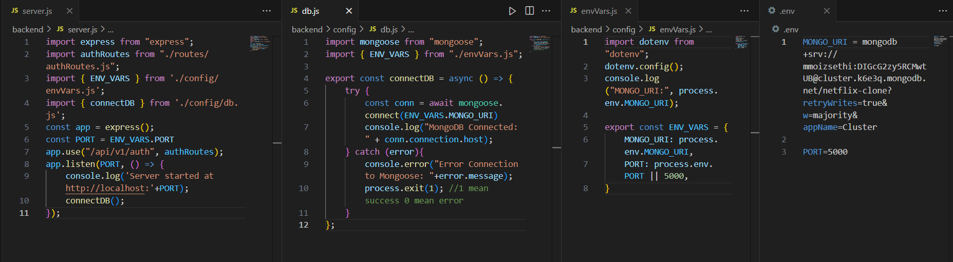

**Database Schema & Database Successful Test**

In model folder we define the schema of the database for example if we want to create schema for the user we create the file user.model.js

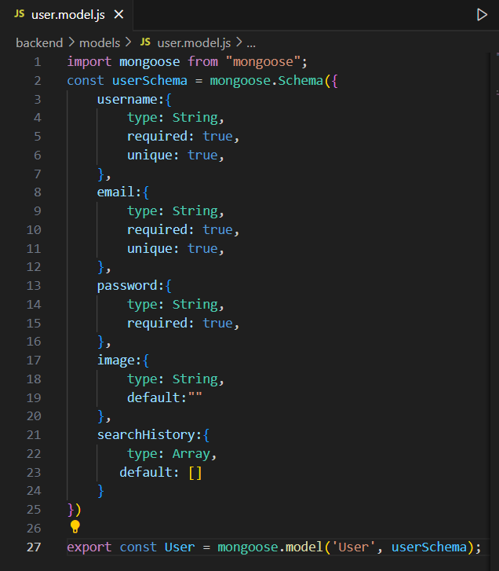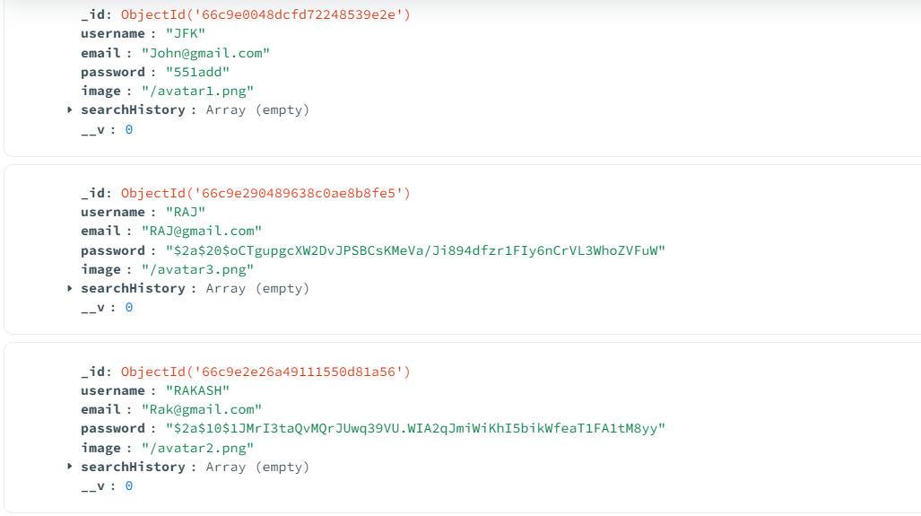

**Bcrypt:**

We use Bcrypt to store our password in hash format we use it in Signup in auth.controller.js file

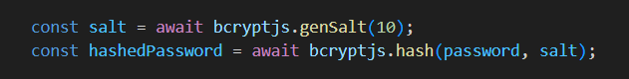

**Generating Tokens for Storing Cookies:**

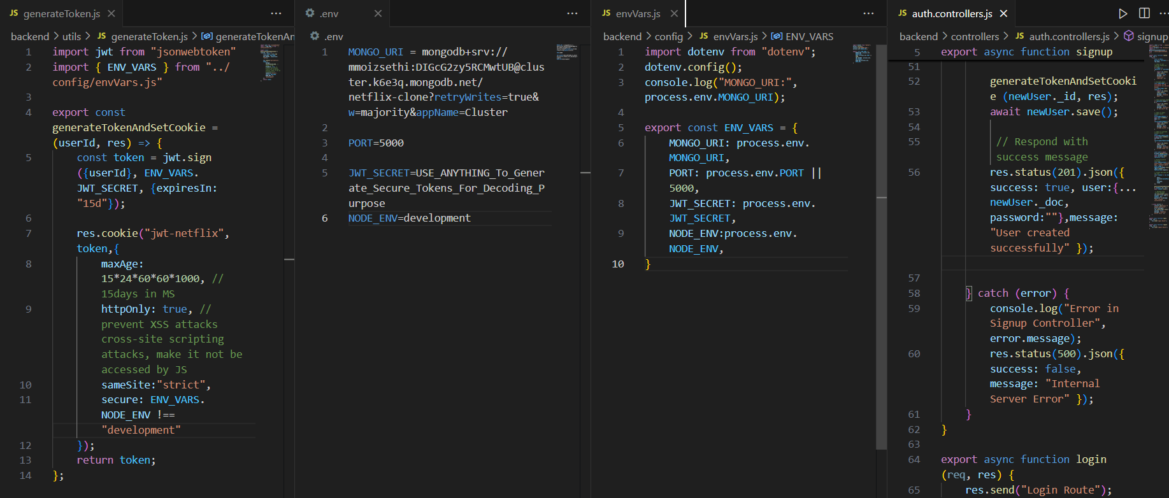

Successfully Generating Tokens tested in postman Secure value becomes true when ssl is activated we set 15 day expiration for the cookies

